|  |
| --- |
| EaseMyTrip– My Info Module (PMI) Live Project |
| **Project Functional Requirement Specification Version 1.0** |
|  |
| **Prepared by: Marri Tejaswini(845202)**  **Taruni Latha Paleti(844884)**  **Chunduri Kalyan Babu(845190)**  **Mahesh Bathula(844906)**  **Anjali Chintham(845191)**  **Subhashini Baddula(844905)**  **Reviewed by: Raghavendra BN** |
|  |
|  |

|  |
| --- |
|  |

Contents

1. Purpose of the document: 2

2. Project Overview: 3

2.1 Audience: 3

2.2 Software and Hardware Components: 3

3. Information Architecture: 3

3.1 Registration: 3

3.2 Login: 4

3.3 Booking Tickets: 5

3.3.1 Flights: 5

3.3.2 Hotels: 11

3.3.3 Trains: 13

3.3.4 Bus: 16

3.3.5 Holidays: 18

3.3.6 Cabs: 20

3.3.7 Visa: 22

3.3.8 Activities: 23

3.3.9 Gift Card: 24

4. Payment: 25

5. Cancellation: 26

6. Special Offers: 27

7. Log Out: 28

# 1. Purpose of the document:

This is a guide intended to booking tickets for Flights, Hotels, Trains, Bus, Holidays, Cabs, Visa and Activities also to send gift cards on special days in [www.easemytrip.com](http://www.easemytrip.com)

This document is divided into three sections:

• Project Overview

• Information Architecture

• Site Design

# 2. Project Overview:

## 2.1 Audience:

**EaseMyTrip** is an Indian online travel company founded in May 2008 by Nishant Pitti and Rikant Pitti. Headquartered in New Delhi, the company provides hotel bookings, air tickets, holiday packages, bus bookings, and white-label services. By reading this guide, you will learn how to use EaseMyTrip through the elements of the graphical user interface and what's behind some of the advanced features that are not always obvious at first sight. It will hopefully guide you around some common problems that frequently appear for users of EaseMyTrip.

## 2.2 Software and Hardware Components:

EaseMyTrip servers will be useful for the comfort of travellers to book tickets based on their interests. It requires Hardware component as a desktop or a laptop and Software component as a software application that is search engines. Examples like Google chrome, Browser, Internet Explorer etc.

# 3. Information Architecture:

## 3.1 Registration:

Open the URL [www.easemytrip.com](http://www.easemytrip.com). For new users, registration can be done by clicking Register at right top corner in My Account. Enter the mobile number or Email for creating new account as shown in figure 1.0

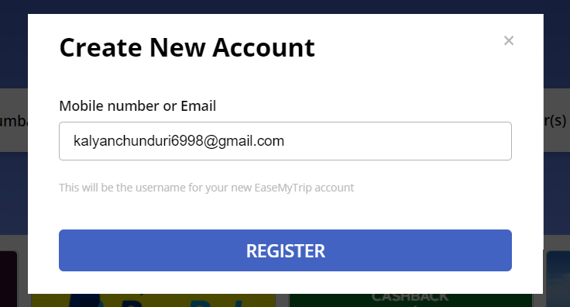

Figure 1.0

After clicking Register, it will direct to new screen for entering the OTP which has been sent to your registered Email or mobile number and create your password as shown in figure 1.1

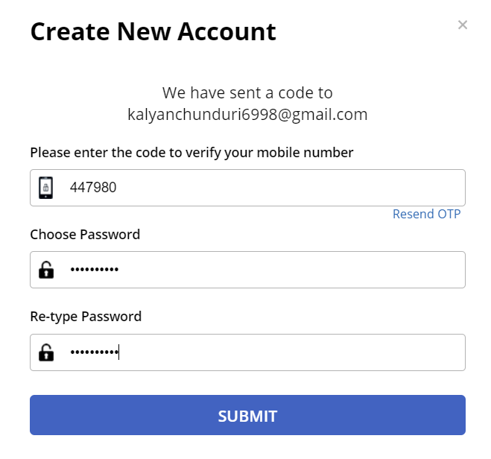

Figure 1.1

## 3.2 Login:

After submitting successfully your EaseMyTrip account has been created then login by using registered Email and password as shown in figure 1.2

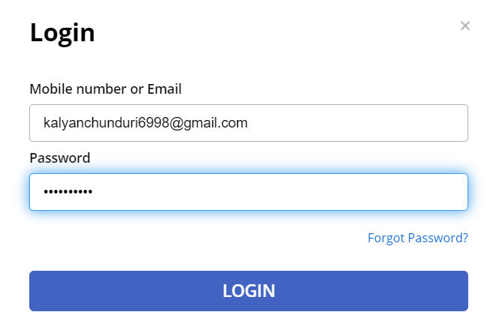

Figure 1.2

## 3.3 Booking Tickets:

` After login, you can find different categories like Flights, Hotels, Trains, Bus and Holidays Etc.

### 3.3.1 Flights:

Enter the From, To, number of travellers, select the date of journey and economy.

For One Way you can only select the date of going as shown in figure 1.3

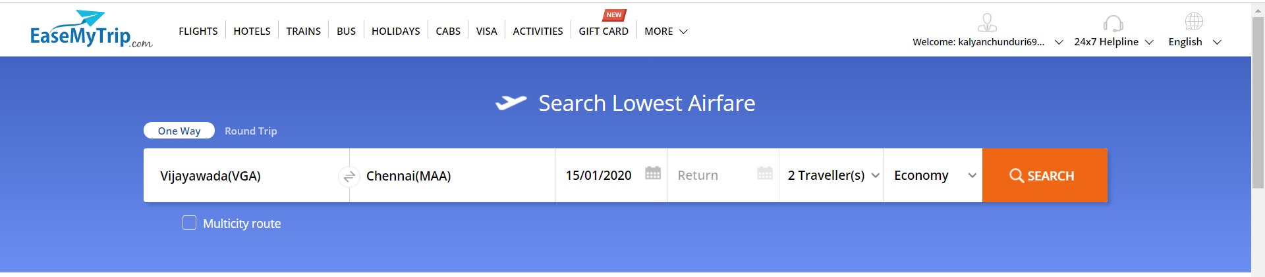

Figure 1.3

After clicking search, you will find the available flights, its timings and price as shown in figure 1.4

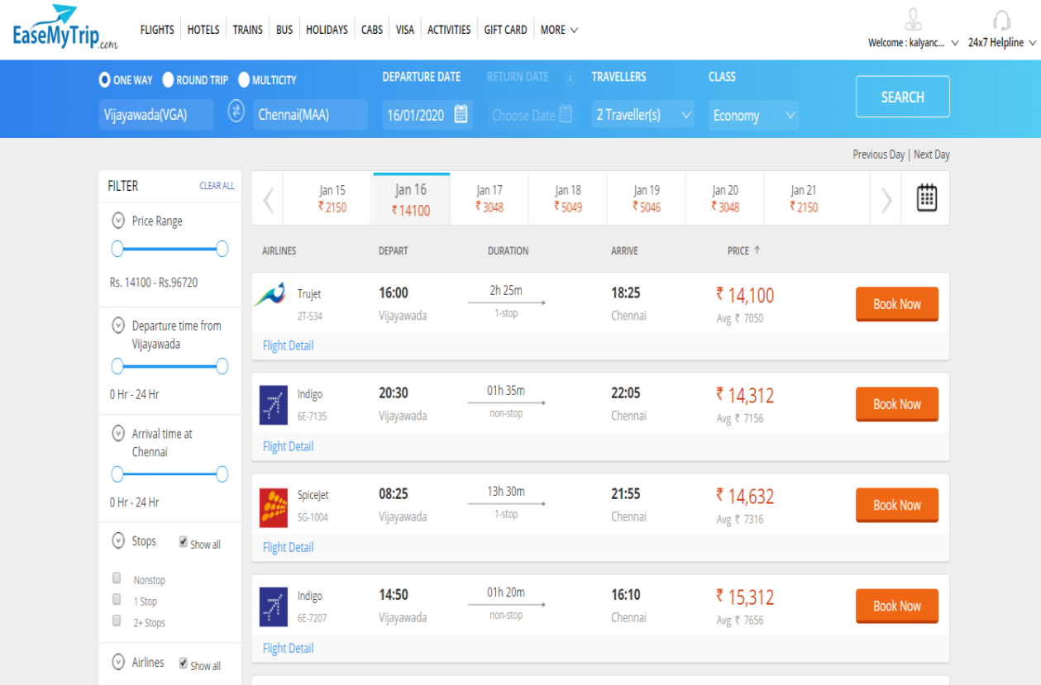

Figure 1.4

Choose the required flight and click Book Now for booking. It displays the Flight details, price summary and enter Email address which you want to receive your ticket confirmation details as shown in figure 1.5

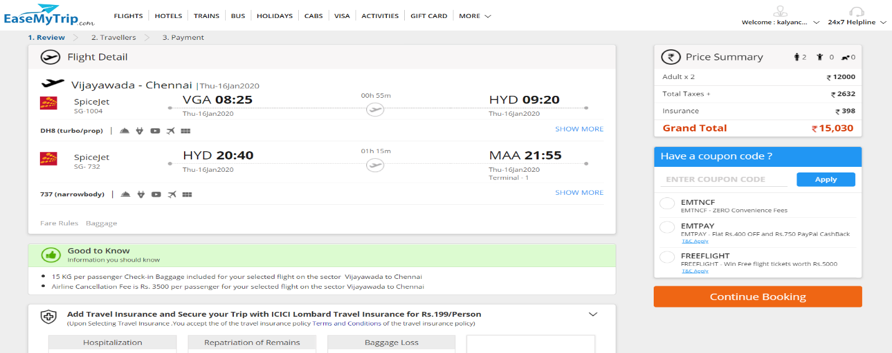

Figure 1.5

Fill the passenger details like name of the passenger and mobile number for confirmation and click on continue booking as shown in figure 1.6

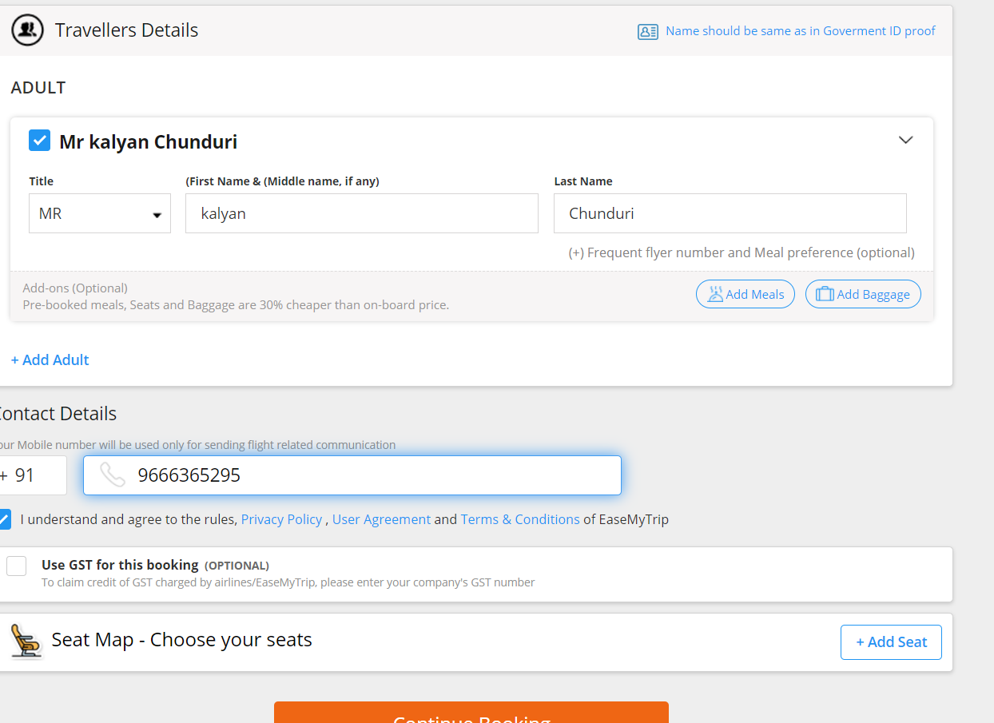

Figure 1.6

Then it will direct to the payment page.

For Round Trip you want to select the date of return as shown in figure1.7

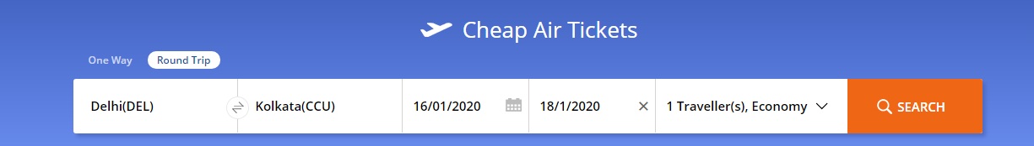

Figure 1.7

After clicking search, you will find the available flights, its timings and price as shown in figure 1.8

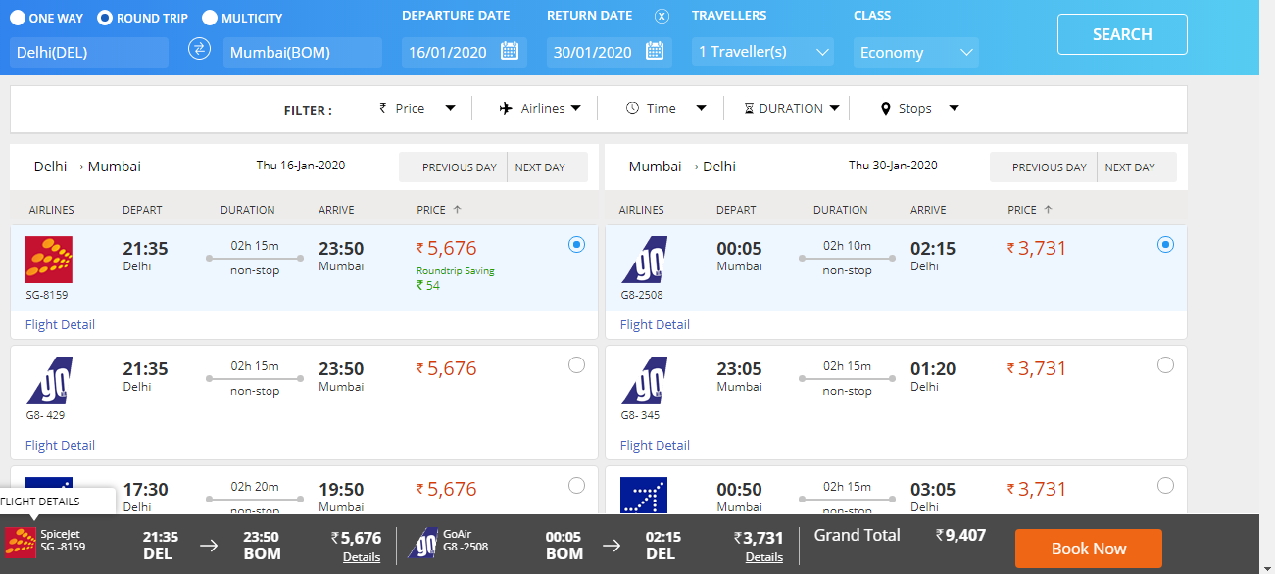

Figure 1.8

Choose the required flight and click Book Now for booking. It displays the Flight details, price summary and enter Email address which you want to receive your ticket confirmation details as shown in figure 1.9

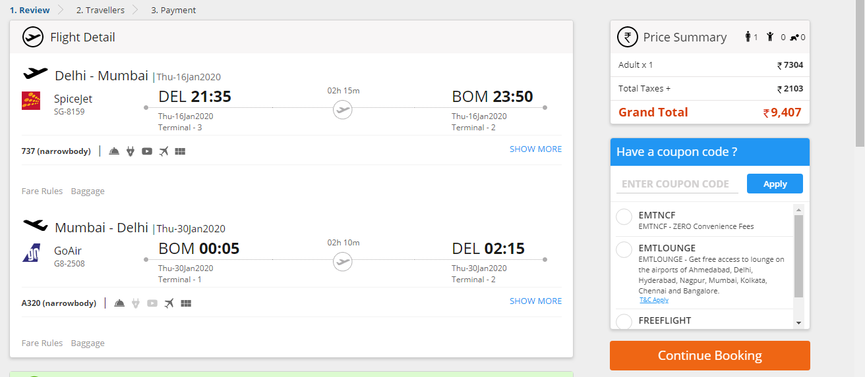

Figure 1.9

Fill the passenger details like name of the passenger and mobile number for confirmation and click on continue booking as shown in figure 2

Figure 2.0

Then it will redirect to the payment page.

For Multicity, Enter Multiple source and destination with different departure date. It can be done as shown in the figure 2.1.

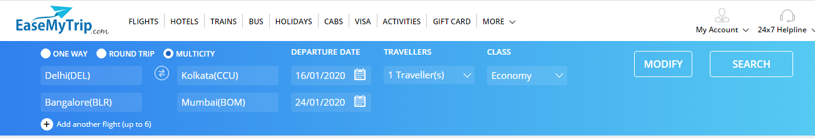

Figure 2.1

It will show all the available flights. Based on preferences and comfort select the particular flight and click on Book as shown in figure 2.2

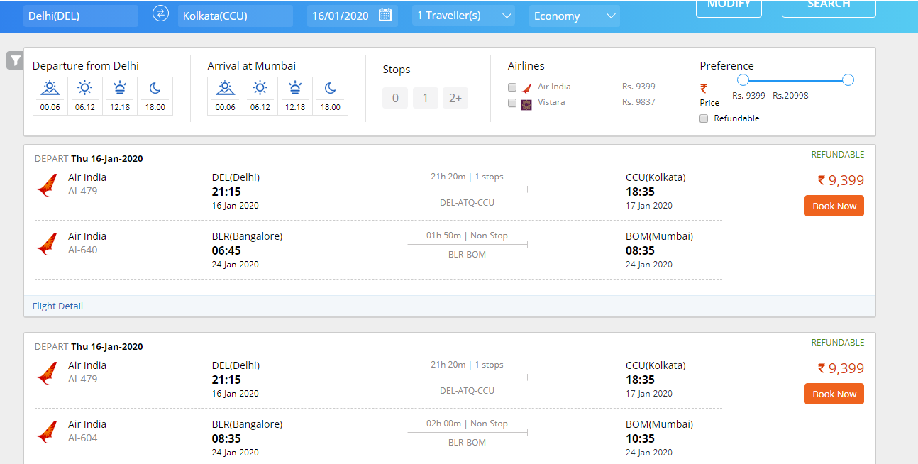

Figure 2.2

After clicking book option, it will redirect you to enter the traveler information such as:

* Travelers name.
* Mobile Number.

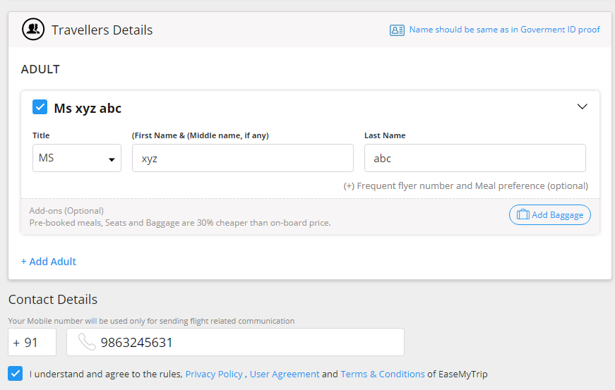

Figure 2.3

After proceeding it will redirect to the payment page.

### 3.3.2 Hotels:

Enter the name of the city, check-in date, check-out date, number of rooms to be booked and number of guests. Click on SEARCH.

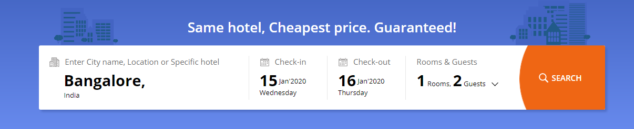

Figure 2.4

It provides the list of hotel rooms available in the particular location and click on Select Room as shown in figure 2.5.

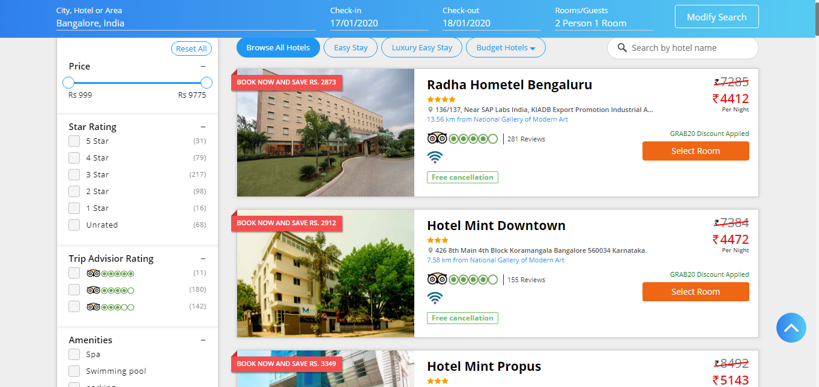

Figure 2.5

Select the type of room like deluxe room, superior room, single room, double room etc and click on Select Room as shown in figure 2.6.

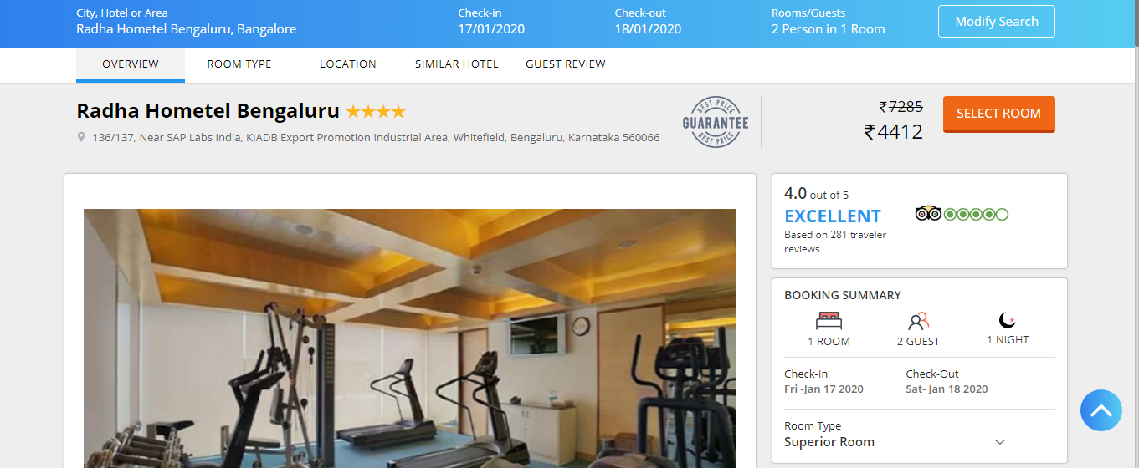

Figure 2.6

Enter the names and details of the guests staying in the room and it will direct to payment page as shown in figure 2.7.

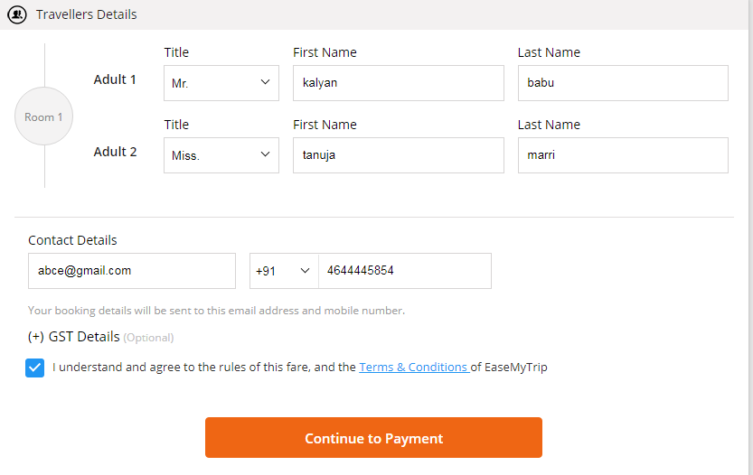

Figure 2.7

### 3.3.3 Trains:

Enter From location, To location and Departure date in Trains Between Stations as shown in figure 2.8.

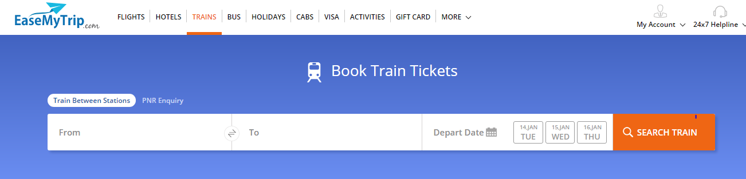

Figure 2.8

It gives all the list of trains scheduled to the particular destination. Go and check the availability and it gives the fair details according to the availability of the seats. Then go to the book now option to book the tickets as shown in figure 2.9.

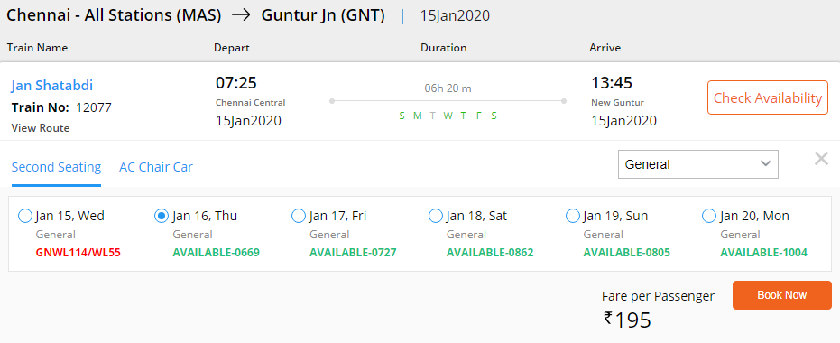

Figure 2.9

The following are the fields need to enter are:

* IRCTC User ID
* Traveller Information
* Email ID and Mobile Number

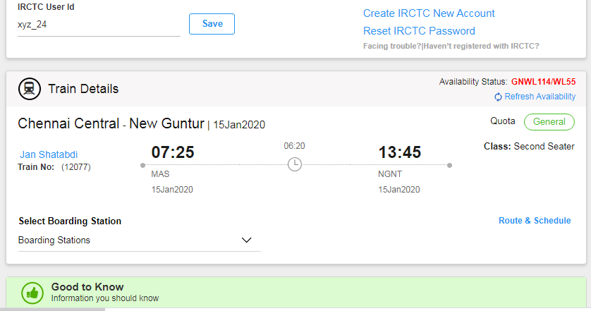

Figure 3.0

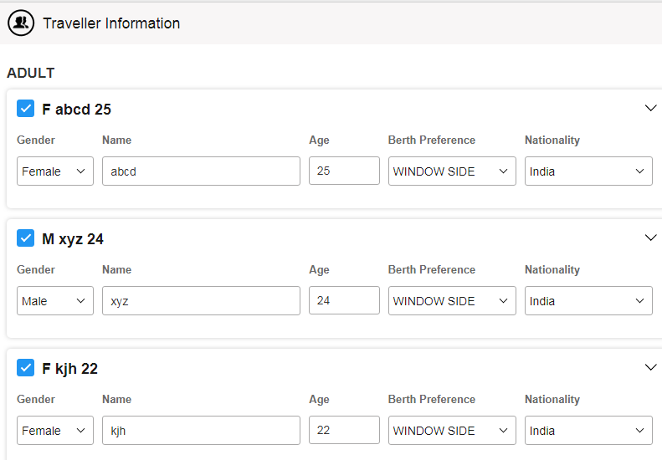

Figure 3.1

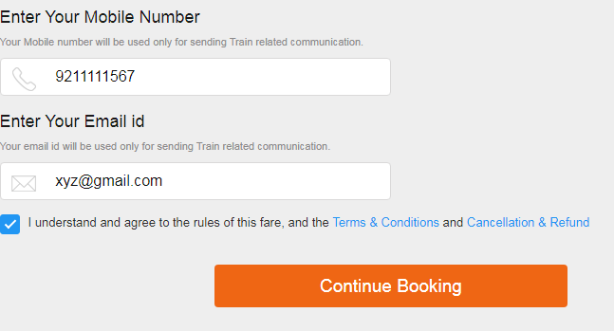

Figure 3.2

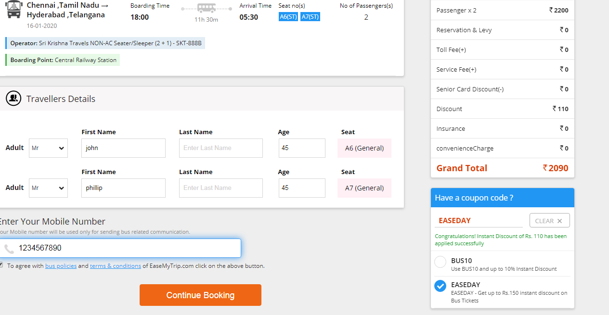

Figure 3.3

After clicking continue booking it will direct to payment page.

Also know status of your train ticket and chances of W/L information through PNR number in PNR Enquiry as shown in figure 3.4.

Figure 3.4

### 3.3.4 Bus:

Enter the names of Source City and Destination City, select the date and number of seats to be booked and click on search as shown in figure 3.5.

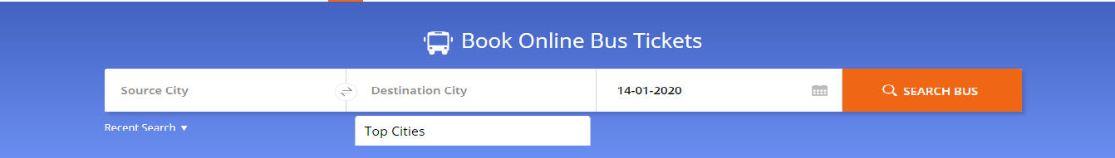

Figure 3.5

It shows the list of buses available in the particular location.

Select the buses which you like depends on price, timings and duration as shown in figure 3.6

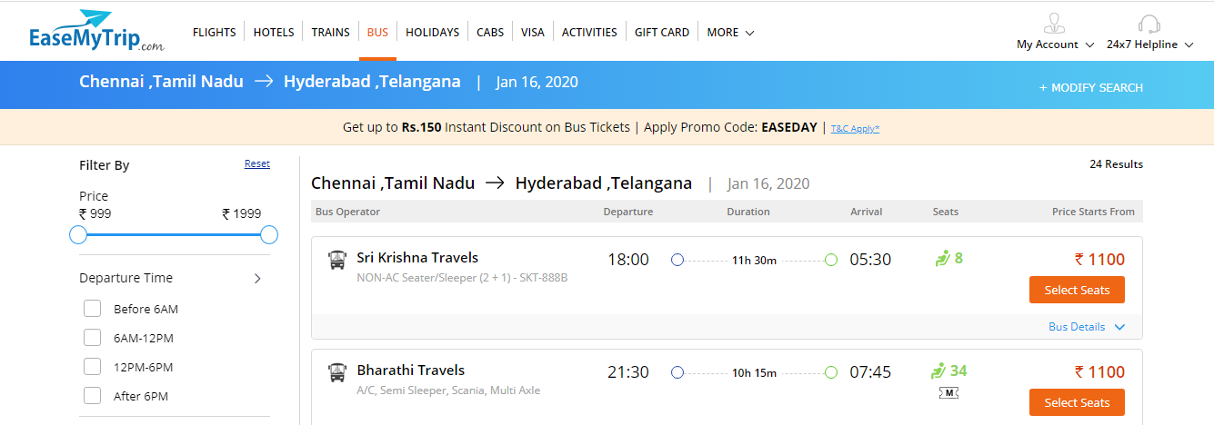

Figure 3.6

Select the seats type of you want like AC, non-AC, sleeper, semi-sleeper, seating etc as shown in figure 3.0

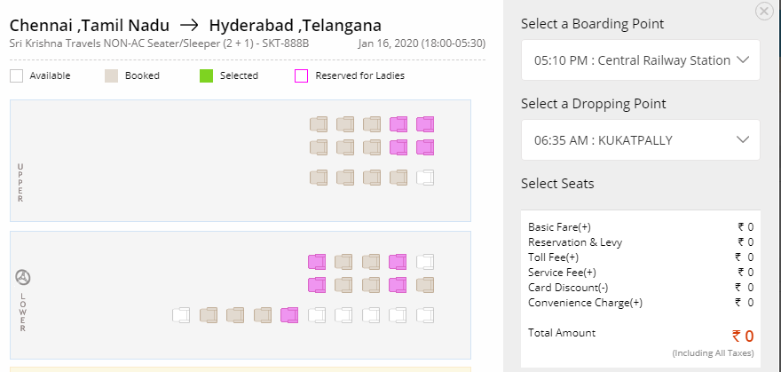

Figure 3.7

Fill the passenger details like name of the passenger and mobile number for confirmation and click on continue booking as shown in figure 3.8

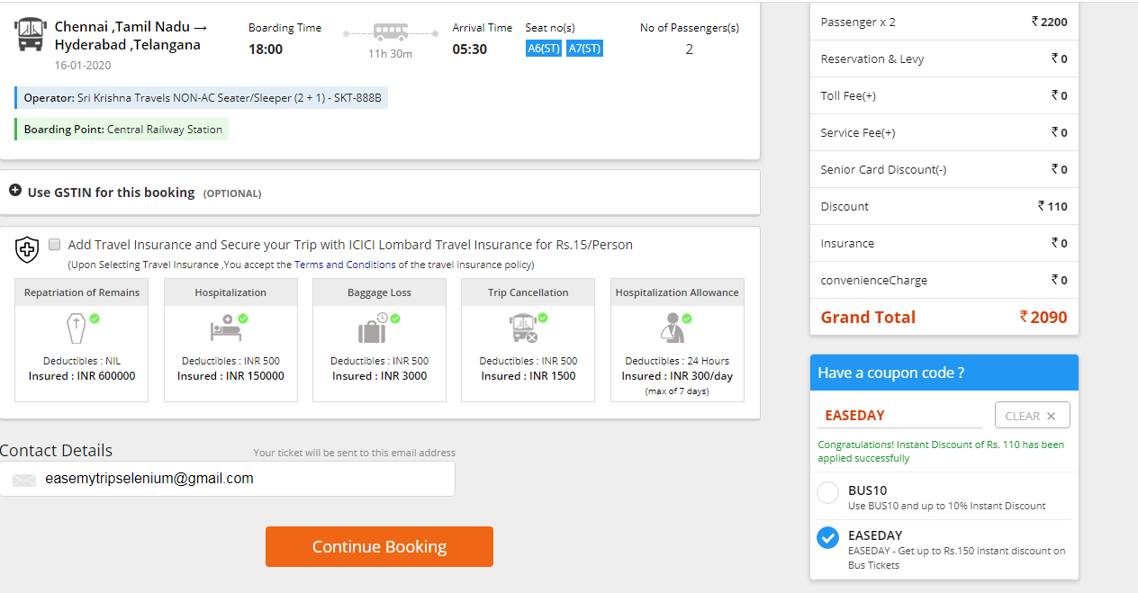

Figure 3.8

Finally it will direct to the payement page.

### 3.3.5 Holidays:

Search holiday tour packages where you want to go. It will show as shown in figure 3.9.

Figure 3.9

Enter the holiday spot that you are interested to go and click on Search as shown in figure 4.0

B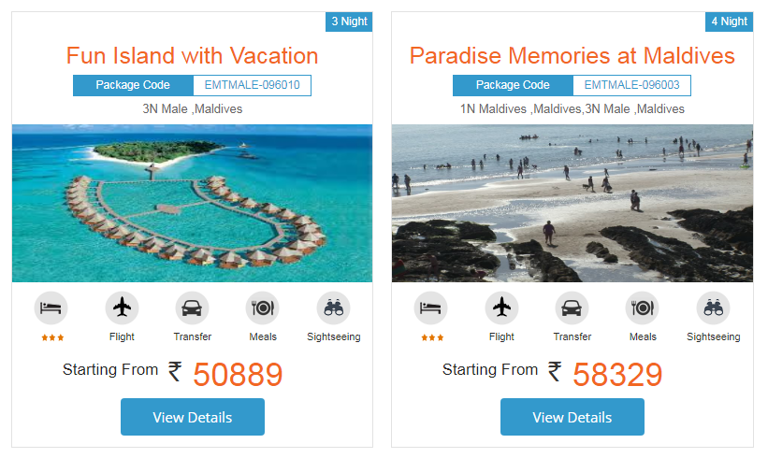

Figure 4.0

Want to go for a memorable holiday then provide details like International/ Domestic, Package Name , City of Departure, Date of Departure and contact details like Name, Email Id and phone number as shown in figure4.1.

Figure 4.1

Click on Submit as shown in figure 4.2

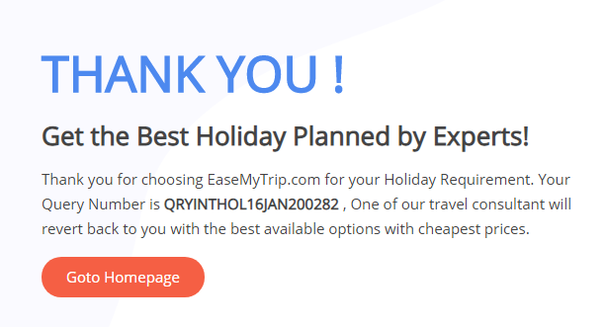

Figure 4.2

A query number is assigned to know the information about journey details. A travel consultant will revert back to you with available options with cheapest prices. After filling all the necessary details then click submit it will direct to Payment Gateway.

### 3.3.6 Cabs:

Here you can find Outstation, Airport Transfer and Rentals cars

In Outstation One Way and round trio are available. Enter I want a car from, I want a car to, select pick up time and date of journey in One Way, In Round Trip select extra return journey date also. It will be as shown in figure 4.3.

Figure 4.3

In Airport Transfer, Airport Pickup and Airport Drop are available. Enter I want a car from, I want a car to. Select date of journey and pick up time then click search as shown in figure 4.4.

Figure 4.4

In Rentals, Enter I want a car, Package in Hours, Kilometers and select date of journey, pick up time as shown in figure 4.5.

Figure 4.5

Click search button after entering your require details then search results are as shown in the figure 4.6.

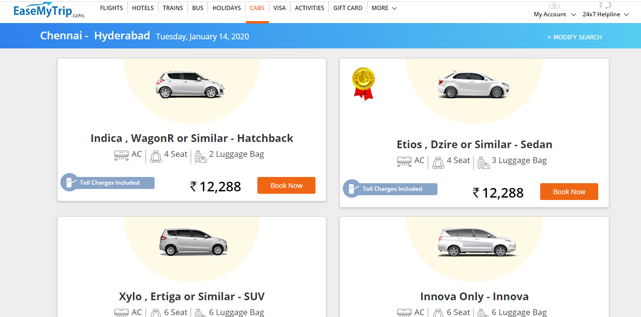

Figure 4.6

Book according to your requirements like AC, Seats and luggage bags.Then click Book Now. It shows the Review and Travellers page. Fill all the further detalis as shown in figure and figure 4.7.

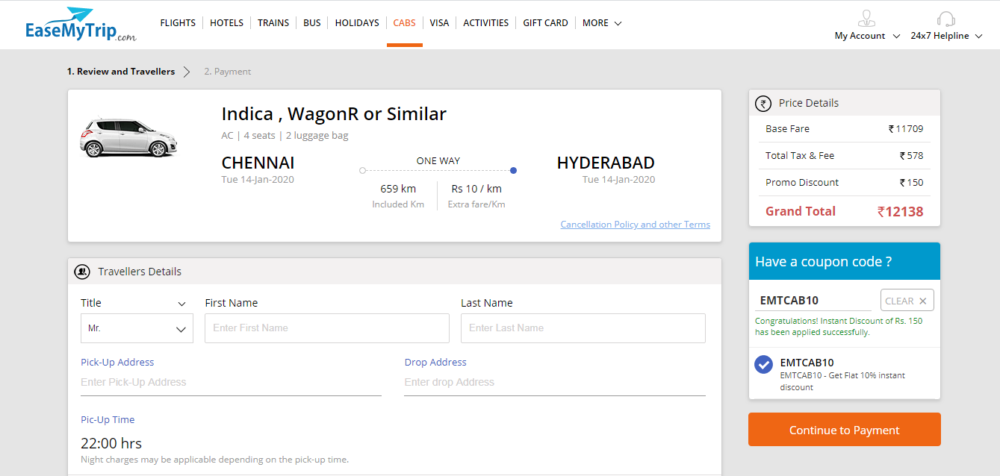

Figure 4.7

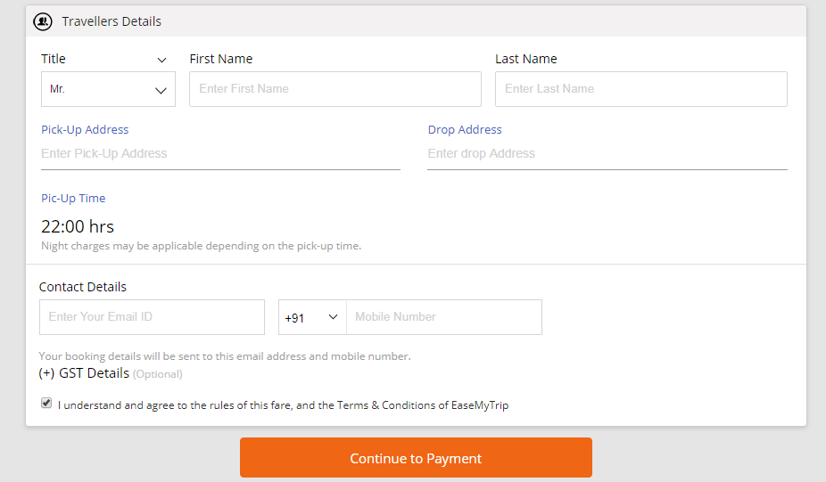

Figure 4.8

After entering all the necessary details then it will direct to the payment page

### 3.3.7 Visa:

Select and Book visa for countries around the World, Enter Destination Country, Type of visa, Location and Communication details as mobile number and Email address as shown in figure 4.9.

Figure 4.9

Click Get Quote, Continue, enter Date of Travel, Number of Travellers and continue. It will be as shown in the figure 5.0.

Figure 5.0

By clicking Book Now. It will direct to payment gate way.

### 3.3.8 Activities:

Select the activities like Camping, Cycling, Adventure, Fishing, Fly Sky, Night Life, Food Tour etc by entering the location as shown in figure 5.1.

Figure 5.1

After click Book Now, select package, pick a date, children, adult and click Book Now, Fill the Travellers details and Contact details as shown in figure 5.2.

Figure 5.2

By clicking Continue to Payment it will proceed to payment gate way.

### 3.3.9 Gift Card:

Choose gift card and enter Denomination, Select Quality, Delivery Date, Sender and Receiver details as shown in figure 5.3 and click Pay Now.

Figure 5.3

By clicking Pay Now, It will direct to the payment page.

# 4. Payment:

Payment Gateway will be opened. It has different payment modes. They are as follows:

* Debit/Credit card
* Net Banking
* My Wallet
* UPI

Choose any one of the payment mode.

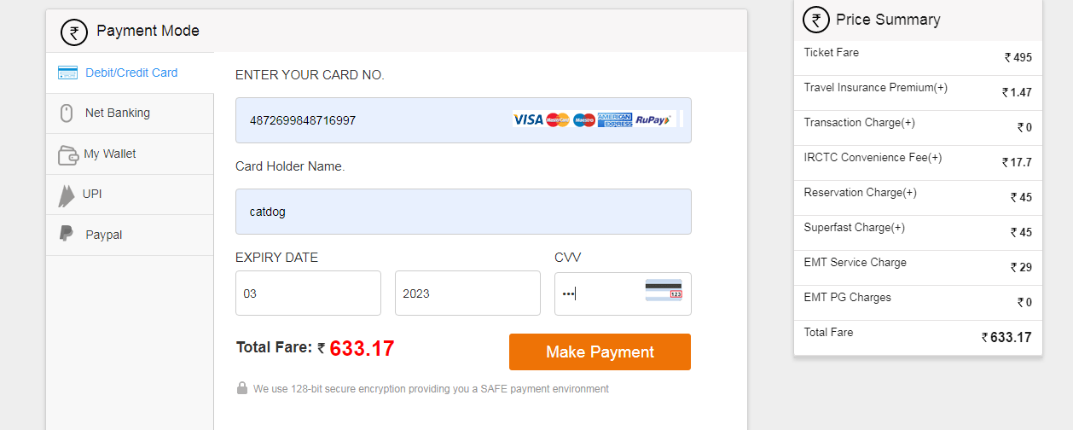

Figure 5.4

Enter the required details as per the selected payment mode. The transaction will be processed. It redirects to specified bankers page. After entering the OTP the tickets are going to confirmed.

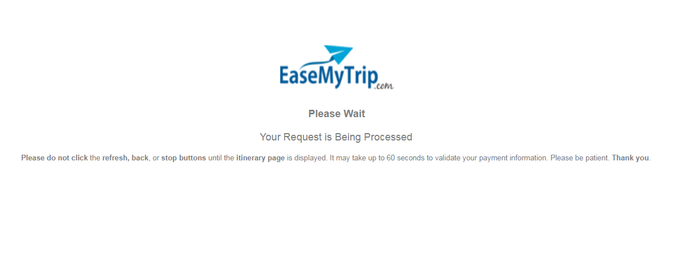

Figure 5.5

# 5. Cancellation:

Enter reference ID and registered email addresses and clicks on Submit to cancel the tickets as shown in figure 5.6

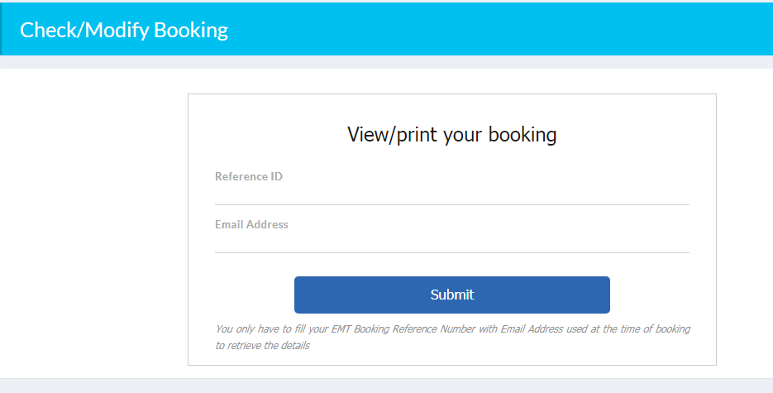

Figure 5.6

* Easemytrip will process the refund only after getting cancellation request/claim from the customer/travel agent/corporate company through my booking section or email.
* Refund against the cancellation of air tickets will be credited directly in customer’s mode of payment after receiving the refund amount from the Airlines.
* EasemyTrip will process refund within 72 only after receiving it from the concerned Airlines/hotel/transporter/other suppliers.
* Due to Banking Procedures, Refund in credit cards may take duration of 72 hours while it may take 7 days in case of net banking transaction.

# 6. Special Offers:

EaseMyTrip provides amazing deals, offers, cash backs and discounts.

You can grab all the offers and discounts at <https://www.easemytrip.com/deals.html>

and you can find as shown in figure 5.7

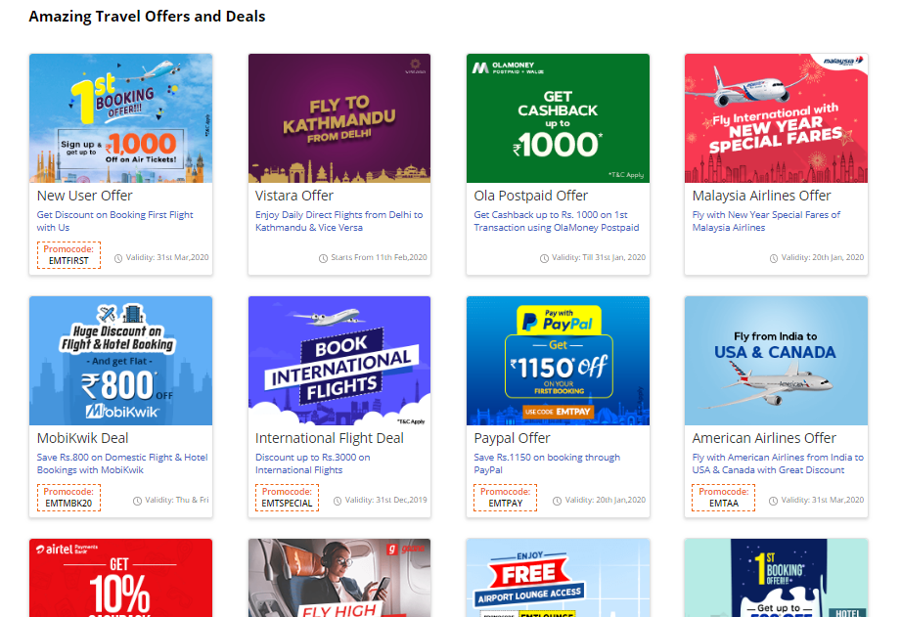

Figure 5.7

# 7. Log Out:

After the process done you may sign out your account by clicking Log Out as shown in figure 5.8

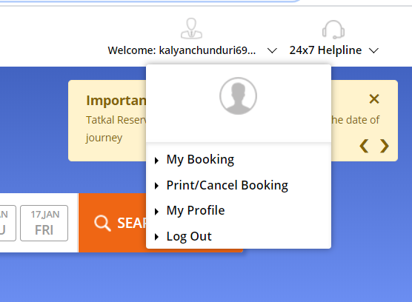

Figure 5.8